FINAL MAJOR PROJECT

## Part 1: Project Proposal

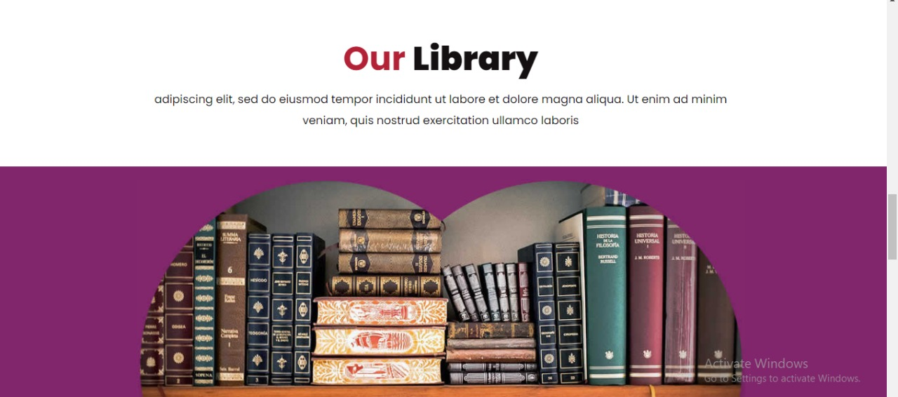

Step 1: Memorial.com web-app development final major project in ASP.NET

**Systems Analysis –** ASP.NET was used to create this platform. The ability to manage libraries is an important feature. We focused on user needs while developing the target system's requirements, which included learning about software product restrictions, system-related difficulties or adjustments, and addressing the project's impact on the organisation and workers, among other things.

Based on these findings, the project team developed a timeline and resource allocation plan for the project.

**Systems design** – This is a high-level description of how a computer-based system would satisfy the requirements; it is expected to be a single-user system that does not rely on data connection for the main facility.

**Systems Specifications**

OS -Windows 10

IDE- Visual Studio

**Programming** – ASP.NET and C# was used to the nominated functionality completed as a working system in an MVC model.

Step 2***:*** Produced a project proposal contained that includes manage libraries, order, and User login etc.

Project Goal – Build a platform for users to manage libraries.

Project Objectives – The main objectives of the project was to enable users to manage libraries easily and provide an optimal user interface and user experience

Project Scope – A full-fledge website develop 5 page website development

1. Context – A manage libraries facility
2. ASP.NET language platform
3. Stakeholders of the product: People who want to manage libraries
4. Backend or API integration

Project Deliverables –

1. Analysis documentation
2. Design documentation
3. Executable program
4. User documentation

|  |  |  |
| --- | --- | --- |
| **Milestone** | **Time taken** | **Finalized** |
| Designing | 2 Days | Yes |
| Programming | 2 Days | Yes |
| Documentation | 2 days | Yes |

Resources

|  |  |
| --- | --- |
| Processor | 1 GHz |
| RAM | 512 MB |
| Disk space (minimum) |  |
| 32-bit | 4.5 GB |
| 64-bit | 4.5 GB |

ProjectMilestones

|  |  |  |
| --- | --- | --- |
| **Milestone** | **Time taken** | **Finalized** |
| Designing | 2 Days | Yes |
| Programming | 2 Days | Yes |
| Documentation | 2 days | Yes |

ProjectSchedule

1. The conclusion of the preliminary inquiry

2. Drafted design

3. Approval of the design

4. The prototype programme has been finished.

5. Signed-off stages of programme refinement

6. The programme has been completed.

7. The programme was put to the test

8. Completed system documentation

9. The user acceptance process has been finished.

10. Completion of the user report on system acceptability

Project Assumptions

1. Users are available during the project to provide information and software is available at the client site.

# **Design**:

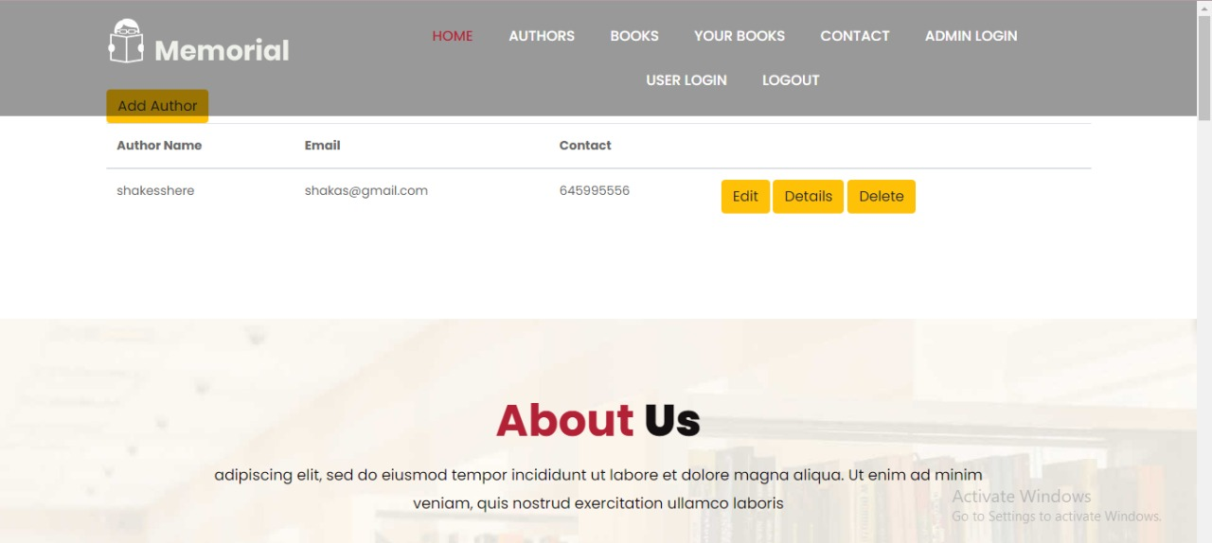

Admin Details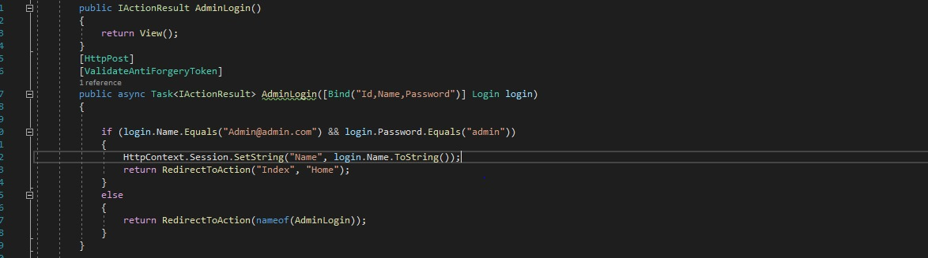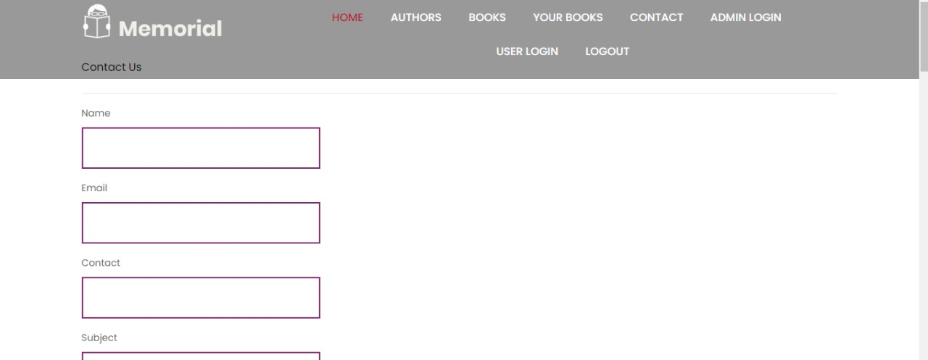

Main Page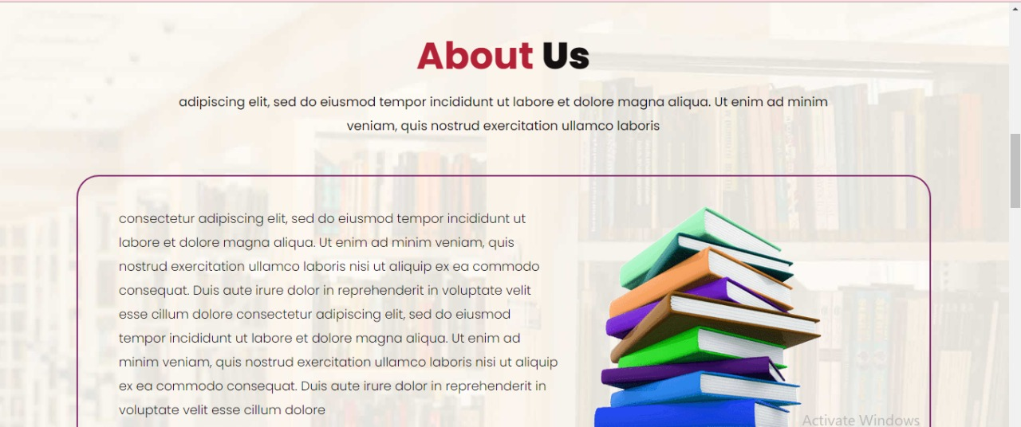

About Us

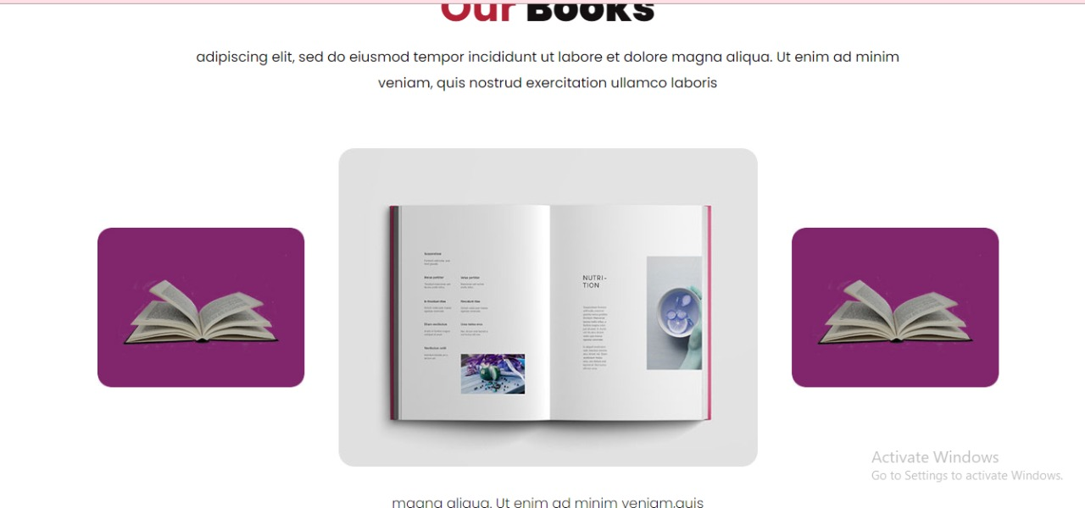

# **Part 2: Review your project**

Step 1: Final Product/Outcome - a platform to manage libraries